SIMATS ENGINEERING
Department of Computer Science and Engineering

CSA15 Cloud Computing and Big Data Analytics
CO4 AT2 – Big Data Industry Problem Solving Guided Tool Workbook
Course Code | CSA15 | Slot | B
Assessment | CO4 AT2 | Bloom Level | BL4 – Analyze
Faculty | Dr C. Rajesh Babu | Employee ID | SSETSCS415
Mode | Individual guided tool-based workbook | Submission | GitHub repository link through Google Classroom
End Evidence | Workbook + screenshots + diagrams + dashboard/mockup | Marks | 30

Student Details
Student Name | T.PRAKEERTHI | Register Number | 192524279
Class / Section | B.Tech 2nd year | Slot | B
Selected Scenario | Healthcare Emergency Analytics – Medique AI (Hospital OP Queue & No-Show Prediction) | Submission Date | 19 Aug 2026
GitHub Link | https://github.com/tarigondaprakeerthi/CSA1512-cloud-computing-Assessment.git | Google Classroom Status

Workbook Purpose
What this workbook does: This workbook guides students to use real software tools and official technical references to derive a big-data industry solution. Students should learn from the tool, observe patterns, record evidence and then write their own technical explanation.

- Do not copy full text from websites or AI tools.
- Use official references to justify architecture, processing and security decisions.
- Screenshots are evidence; explanations are the actual assessment answer.

Scenario Bank
No. | Scenario | Data Context
1 | Healthcare Emergency Analytics (Selected) | Emergency department data, ambulance updates, bed availability, alerts, treatment delays, OP queue and appointment records.
2 | E-Commerce Customer Behavior Intelligence | Clickstream events, cart abandonment, payment failure, campaign traffic and recommendation impact.
3 | Smart Agriculture Advisory Platform | Weather, soil sensors, crop advisories, pest reports, market prices and farmer app interactions.
4 | Cybersecurity Threat Monitoring | Authentication logs, firewall alerts, API access logs, failed login attempts and suspicious network events.
5 | Public Transport Demand Analytics | Ticketing data, bus GPS, passenger count, route delay, peak-hour demand and crowding alerts.

Selected Scenario and Reason
I selected Healthcare Emergency Analytics for my project, Medique AI: Healthcare Emergency Analytics for Hospital OP Queue and No-Show Prediction. Hospitals struggle with long outpatient (OP) queues, unpredictable emergency-department (ED) load, and a high rate of missed OP appointments (no-shows), all of which waste doctor time and delay care for patients who do show up. The scenario provides rich, continuously generated data — OP appointment bookings, patient check-in/queue events, ED arrivals and ambulance updates, bed availability, and treatment-delay alerts — that is well suited to big-data ingestion, streaming analytics and machine-learning prediction. Medique AI uses this data to predict which patients are likely to miss their appointment, forecast OP queue length and waiting time, and raise real-time alerts when ED load or bed occupancy becomes critical, so hospital staff can rebalance schedules and resources proactively.

Guided Tool Module 1: Use Cloud Architecture Centers
Purpose: Use official cloud architecture references to identify suitable ingestion, storage, processing, analytics and security components for the selected scenario.
No. | Perform | Observe / Decide | Record in Workbook
1 | Open AWS Architecture Center, Azure Architecture Center and Google Cloud Architecture Center in three browser tabs. | You are not copying a full architecture. You are learning common cloud patterns and service categories. | Pasted the three reference URLs (see Cloud Provider table below).
2 | Search each site using terms from the scenario, such as healthcare analytics, hospital appointment analytics, patient no-show prediction, streaming analytics, data lake. | Notice which patterns repeatedly appear: ingestion, data lake/warehouse, stream processing, ML/analytics, visualization and security. | Recorded useful pattern for each cloud provider.
3 | Identify the services/components mentioned in the reference diagrams. | Separate the service category from the vendor-specific service name. Example: object storage is the category; Amazon S3 / Azure Blob Storage / Cloud Storage are service examples. | Completed the tool-neutral category table.
4 | Compare the three references. | Choose the most suitable architecture pattern for Medique AI and explain why. | Wrote architecture justification below.
5 | Draw a provider-neutral architecture in draw.io. | Diagram must show data sources → ingestion → storage → processing → analytics/dashboard → users, with security controls marked. | Pasted the diagram / evidence below.

Cloud Provider | Reference Page / URL | Useful Pattern Found | Useful Service Categories
AWS | https://aws.amazon.com/architecture/ | Data ingestion → Data lake → Processing → Analytics/ML → Dashboard | Storage, Data Processing, Analytics, ML, Visualization, Security
Microsoft Azure | https://learn.microsoft.com/en-us/azure/architecture/ | Data collection → Storage → Processing → Prediction → Reporting | Storage, Analytics, ML/Prediction, Reporting, Security
Google Cloud | https://docs.cloud.google.com/architecture | Data ingestion → Data storage → ML processing → Prediction → Monitoring | Storage, Data Processing, ML, Analytics, Monitoring

Cloud Architecture Justification
For Medique AI, I would choose a data analytics and machine-learning architecture built around a streaming + batch (Lambda-style) pattern. OP appointment, queue and ED data are ingested through an API/ingestion layer and land in centralized cloud storage (a data lake). A processing layer cleans and structures the data, after which an analytics/ML layer calculates queue length, wait-time trends, and a no-show risk score for each upcoming appointment. Results are surfaced through dashboards and real-time alerts for hospital staff and administrators. Security and access controls (authentication, role-based access, encryption) protect patient health information throughout. This architecture is suitable because it supports the storage, processing, analytics, prediction, visualization, scalability and security needs of a hospital-scale healthcare analytics system.

Architecture Diagram Evidence
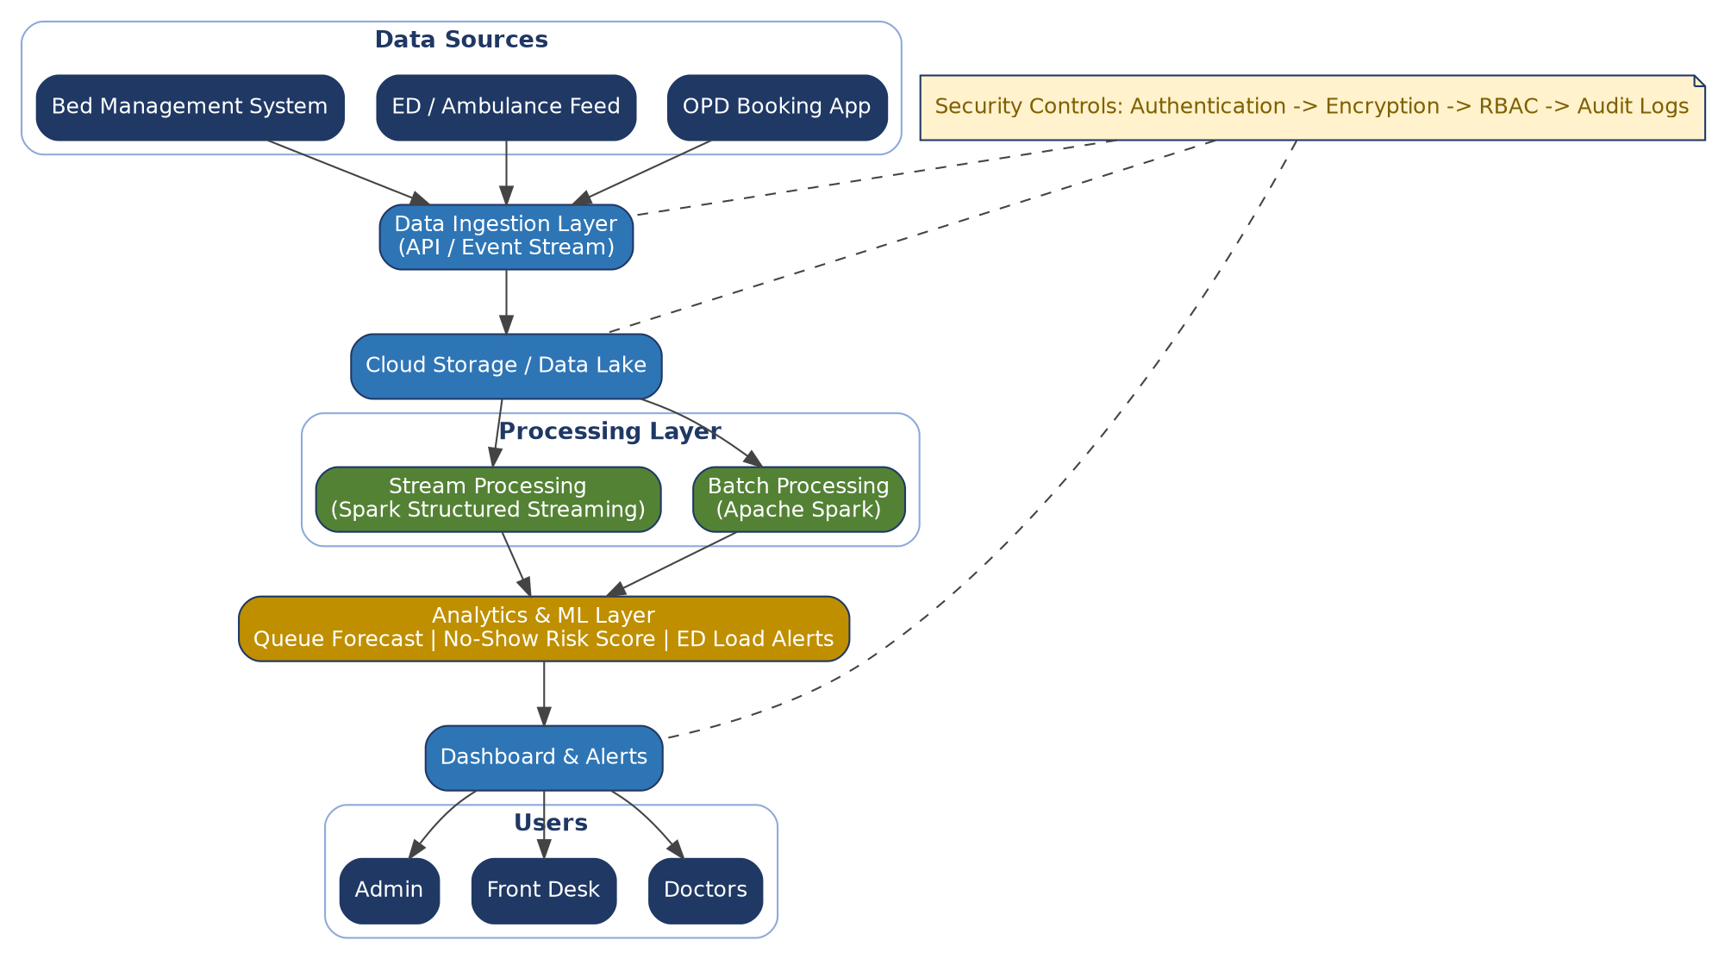
Figure 1: Medique AI cloud architecture — data sources, ingestion, storage, batch/stream processing, analytics/ML and dashboard layers, with security controls applied end to end.

Guided Tool Module 2: Use Hadoop and Spark Documentation
Purpose: Decide whether your problem needs batch processing, streaming processing or hybrid processing by reading official Hadoop/Spark documentation.
No. | Perform | Observe / Decide | Record in Workbook
1 | Open the Apache Hadoop MapReduce tutorial. | MapReduce suits batches such as monthly OP visit history or archived treatment records processed periodically. | Written one sentence on when MapReduce/Hadoop applies to Medique AI.
2 | Open the Apache Spark Structured Streaming guide. | Structured Streaming suits continuously arriving events, such as live ED arrivals, queue check-ins and bed-status updates. | Written one sentence on when Spark Streaming applies to Medique AI.
3 | Classify your scenario data into batch data and streaming data. | Historical OP appointment/visit records normally batch; live queue, ED arrival and bed-status updates normally become streaming data. | Completed the Data Item classification table below.
4 | Choose one processing approach for your scenario: Hadoop/MapReduce, Spark batch, Spark streaming or hybrid. | The decision balances latency and data velocity. | Written processing framework decision below.
5 | Prepare a simple pseudo-flow, not full code. | Example: Map appointment history by department, count no-shows. Reduce sums counts. Dashboard shows peak no-show slots. | Written pseudo-flow diagram below.

Data Item | Batch / Streaming | Why | Suggested Framework
Historical OP appointment records | Batch | Large amounts of past appointment data can be processed periodically to train the no-show model. | Hadoop MapReduce / Spark Batch
Daily OP schedule and completed visit records | Batch | Daily records can be summarized together at the end of the day for reporting. | Apache Spark (batch)
Live patient check-in / queue events | Streaming | Queue position and wait time must update immediately as patients check in. | Spark Structured Streaming
ED arrivals and ambulance updates | Streaming | Emergency events need to be processed and alerted on in near real time. | Spark Structured Streaming
Bed availability updates | Streaming | Bed occupancy changes frequently and drives urgent capacity alerts. | Spark Structured Streaming
No-show risk score / prediction | Batch (model) + Streaming (scoring) | The ML model is trained in batch on history; scores are applied to upcoming appointments continuously. | Apache Spark MLlib + Structured Streaming

Processing Framework Decision
Hybrid processing is most suitable for Medique AI. Spark Structured Streaming processes live ED arrivals, queue check-ins and bed-status updates so that wait-time and capacity alerts are generated with minimal delay. Apache Spark batch processing (with MLlib) analyzes historical OP appointment and visit data to train the no-show prediction model and generate daily/weekly reports. This combination gives hospital staff both immediate operational alerts and a well-trained predictive model for planning.

MapReduce / Spark Pseudo-Flow
OPD & ED Data
|
+---> Live Queue / ED Events --> Spark Structured Streaming --> Wait-Time & Capacity Alerts
|
+---> Historical Appointment Data --> Spark Batch (MLlib) --> No-Show Risk Score
|
v
Queue Forecast & Risk Dashboard
|
v
Doctor / Front-Desk / Admin Decision

Guided Tool Module 3: Threat Modeling with OWASP Threat Dragon / Microsoft Tool
Purpose: Identify privacy and security risks in the big-data solution before proposing controls.
Tool Choice: Use OWASP Threat Dragon if you need a web/desktop cross-platform threat modeling tool. Use Microsoft Threat Modeling Tool when a Windows system is available. The required evidence is the threat model diagram and threat-control table.
No. | Perform | Observe / Decide | Record in Workbook
1 | Open OWASP Threat Dragon or Microsoft Threat Modeling Tool. | A threat model is a security diagram that shows components, data flows, trust boundaries and possible threats. | Wrote which tool you used.
2 | Create a new threat model named with your scenario. | Use a clear title such as CO4_AT2_Medique_AI_Healthcare_Emergency_Analytics. | Pasted model name.
3 | Add external entities. | External entities are users/systems outside the platform: patient, hospital staff, ambulance service, insurance/payment gateway, public OPD booking API. | Listed external entities.
4 | Add processes and data stores. | Processes transform data; data stores hold data. Example: booking API, queue processing service, EHR/appointment database, ML prediction service, dashboard. | Listed processes and stores.
5 | Draw data flows and trust boundaries. | Trust boundaries mark where security assumptions change: public internet to cloud, app to API, processing layer to storage. | Pasted screenshot of DFD.
6 | Identify threats using STRIDE thinking. | Spoofing, Tampering, Repudiation, Information Disclosure, Denial of Service and Elevation of Privilege help structure risks. | Completed the threat table.
7 | Write mitigations. | Controls may include authentication, authorization, encryption, masking, audit logs, rate limits, backup and monitoring. | Mapped every threat to a control.

Component / Data Flow | Threat | Impact | Mitigation
Patient login / OPD booking portal | Unauthorized access | Patient health records may be viewed or changed | Strong authentication (MFA) and role-based access control
Appointment data -> Cloud storage | Data leakage of PHI | Sensitive patient/medical information may be exposed | Encryption at rest and in transit; data masking
ED/ambulance data ingestion API | Fake or tampered event data | Wrong bed-availability or queue alerts | Input validation, API authentication and rate limiting
No-show ML prediction service | Incorrect or manipulated training data | Wrong risk scores, biased predictions, poor scheduling decisions | Data validation, model monitoring and periodic retraining checks
Dashboard -> Alerts | Unauthorized alert access | Sensitive patient/queue information disclosed to the wrong staff role | Authorization, secure APIs and audit logs
All data flows | Denial of Service on ingestion API | ED alerts and queue updates delayed during peak load | Rate limiting, auto-scaling and traffic monitoring

Threat Model Diagram Evidence
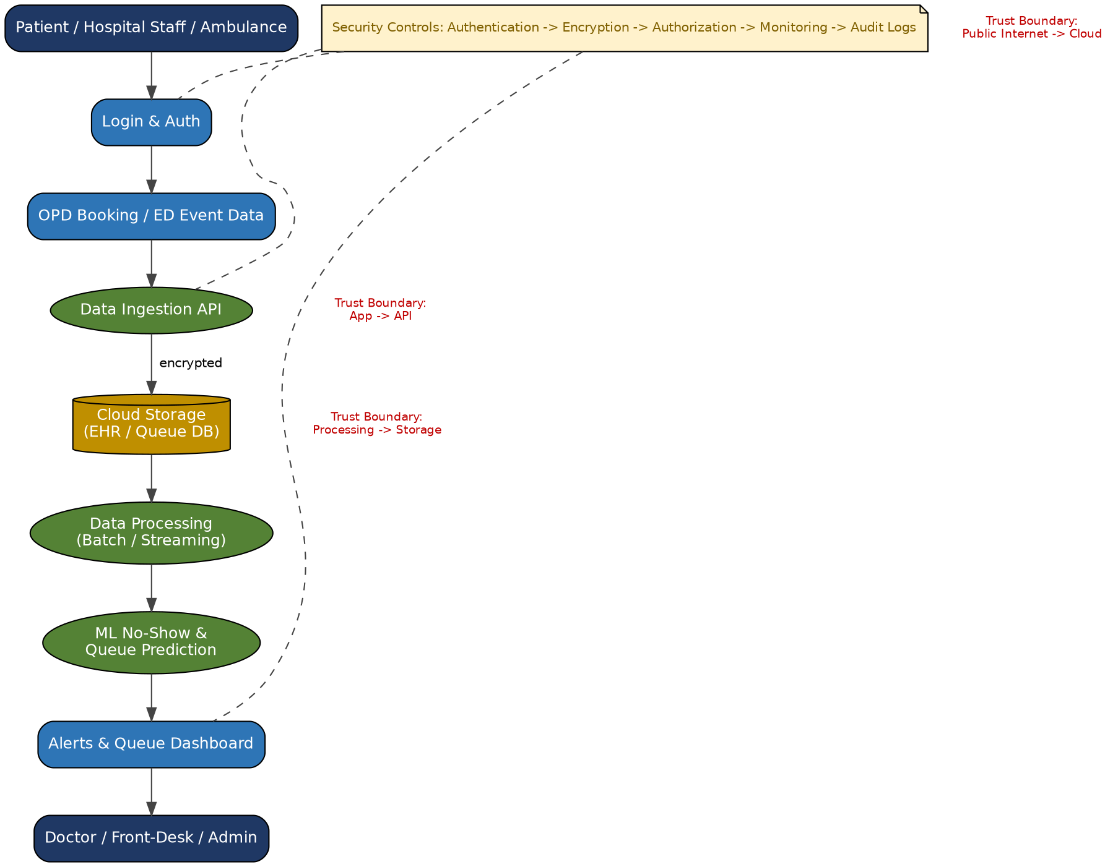
Figure 2: Data-flow diagram showing external entities, processes, data stores, trust boundaries and end-to-end security controls for Medique AI.

Guided Tool Module 4: Dashboard or Analytics Output Mockup
Purpose: Show how raw big data becomes useful decisions through a dashboard, alert, forecast, recommendation or report.
Beginner-Friendly Choice: Use any of Power BI, Looker Studio, Tableau Public or Canva. If login/install is difficult, a Canva dashboard mockup is acceptable. If a live data connection is possible, Power BI/Looker Studio/Tableau Public is stronger.
No. | Perform | Observe / Decide | Record in Workbook
1 | Prepare a small sample dataset in Excel or Google Sheets with 10-20 rows. | Columns should match the scenario. Example: PatientID, AppointmentID, Department, ScheduledTime, ArrivalStatus, QueuePosition, WaitTime, RiskScore. | Pasted column names (see Dataset Columns table).
2 | Choose the dashboard tool. | Power BI/Tableau/Looker are analytics tools; Canva is acceptable for a visual mockup when live data connection is blocked. | Written chosen tool and reason below.
3 | Import or recreate the sample data. | In Power BI/Looker/Tableau, connect the data. In Canva, manually create charts from sample values. | Pasted screenshot of data/chart setup.
4 | Create at least three visual elements. | Use KPI card, bar chart, line chart, table, map, alert count or pie/donut chart as appropriate. | Listed the visuals (see Visual Element table).
5 | Add decision labels. | A dashboard is useful only if it supports a decision: reschedule slots, call at-risk patients, divert ambulances, open extra beds. | Written decision supported by each visual.
6 | Export/share screenshot. | Paste the final dashboard screenshot or public/report link if available. | Pasted evidence below.

Dataset Columns
Column | Meaning | Example Value
PatientID | Unique patient identifier | PT-0142
AppointmentID | Unique OP appointment identifier | APT-8831
Department | OPD department booked | Cardiology
ScheduledTime | Booked appointment time | 2026-08-19 10:30
ArrivalStatus | Whether patient showed up | No-show
QueuePosition | Live position in the OPD queue | 5
WaitTime (min) | Minutes waited so far | 38
RiskScore | Predicted no-show probability (0-1) | 0.78
BedAvailability | Free beds in relevant ward | 3
AlertLevel | Operational alert status | High

Visual Elements
Visual Element | Metric Shown | Decision Supported
KPI card | Today's no-show rate (%) | Decide whether to overbook upcoming slots
Bar chart | OPD queue length by department | Reassign front-desk staff or open an extra counter
Line chart | Average wait time trend over the day | Identify peak hours and adjust doctor rosters
Alert count / KPI card | Available beds by ward | Decide whether to divert ambulances or open overflow beds
Table (ranked) | Top high-risk no-show patients for tomorrow | Contact patients in advance or release the slot

Dashboard / Analytics Output Evidence
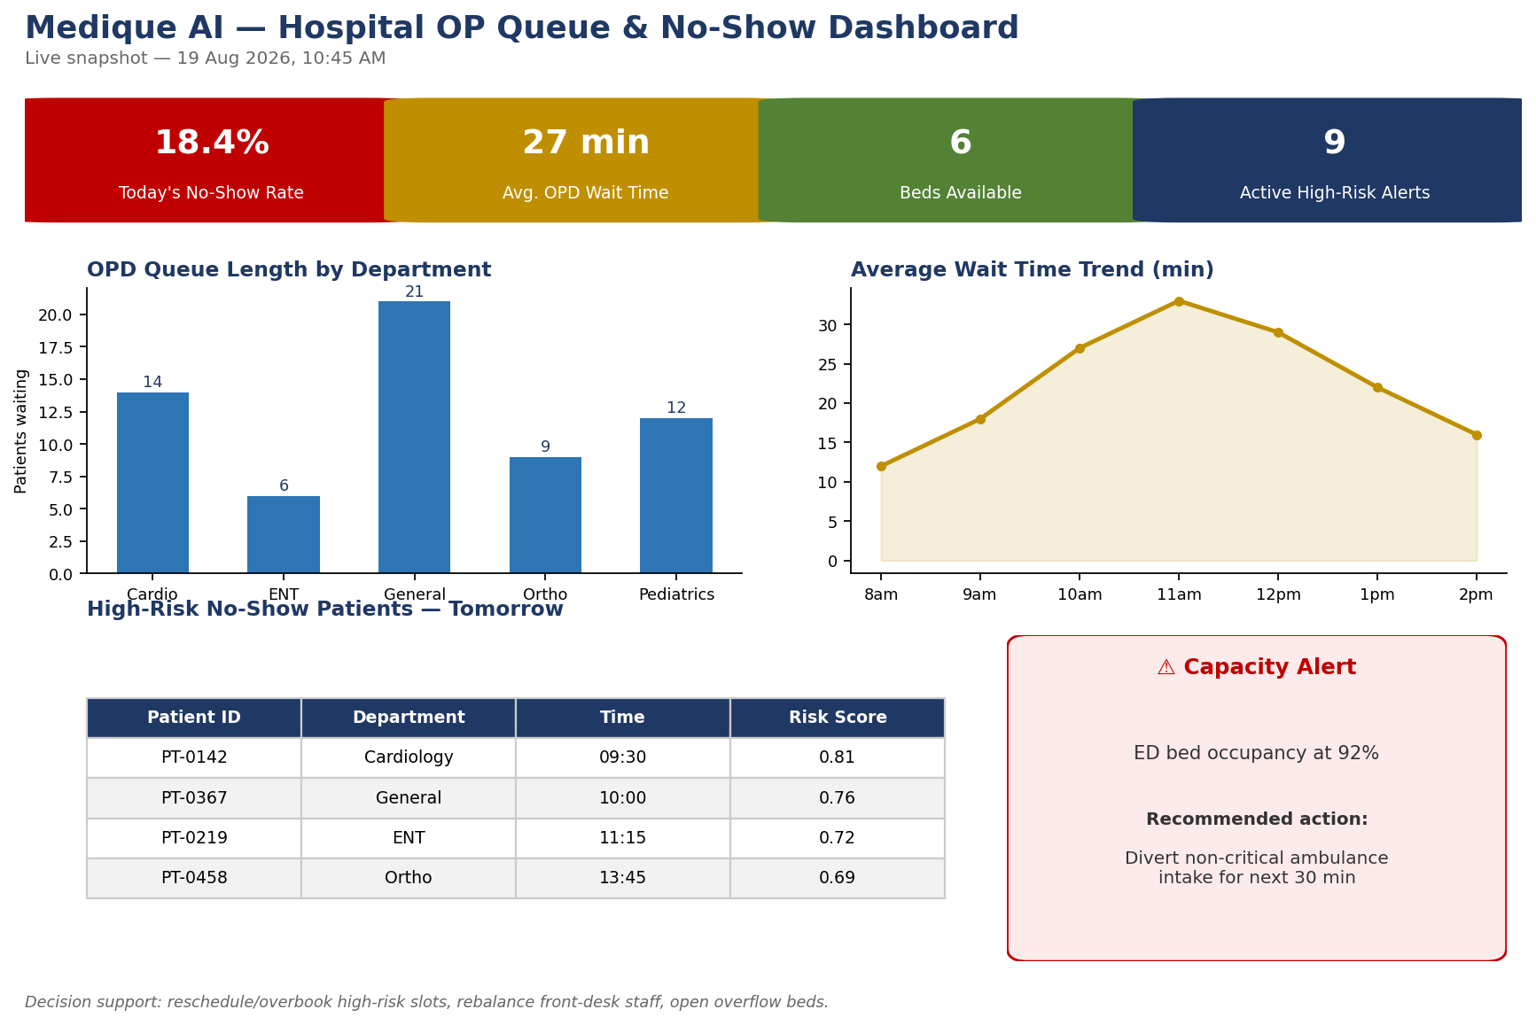
Figure 3: Medique AI dashboard mockup — KPI cards, queue and wait-time charts, high-risk no-show table and a capacity alert panel, each tied to a specific staff decision.

Final CO4 AT2 Solution Sections
Final Assembly: After completing the guided tool modules, combine the evidence into the final solution. The final answer must show technical reasoning, not only screenshots.

1. Problem Understanding
What to include: Identify stakeholders, decisions required, data produced, expected analytics output and urgency.
The main stakeholders for Medique AI are patients, OPD front-desk staff, doctors, ED/ambulance staff, bed-management staff and hospital administrators. Front-desk and OPD staff need to know how many patients are likely to miss their appointment so unused slots can be reused, while doctors and administrators need visibility into queue length, waiting time and ED/bed capacity to plan resources. The system collects OPD booking data, live queue check-in events, ED arrival and ambulance updates, bed-availability data and historical visit outcomes. It analyzes this data to calculate current queue length and wait time, predict the probability that a booked patient will not show up, and flag emergency-capacity issues such as bed shortages or long ED wait times. The expected output is a real-time dashboard and alert system showing queue status, no-show risk scores and capacity alerts. This is urgent because unpredicted no-shows waste limited doctor time and unmanaged queues or bed shortages directly affect patient safety and satisfaction.

2. 5Vs Mapping
What to include: Map Volume, Velocity, Variety, Veracity and Value using scenario evidence.
Volume: The system handles OPD appointment records, live queue events and ED/ambulance updates across many departments, doctors and patients every day, producing a continuously growing dataset.
Velocity: Queue check-ins, ED arrivals and bed-status changes are generated throughout the day and must be processed with low latency so alerts stay useful.
Variety: Data includes structured appointment records, streaming queue/ED events, bed-occupancy figures, free-text treatment-delay notes and generated risk scores and alerts.
Veracity: Patient and appointment data must be accurate and complete, since incorrect check-in or bed-status data can produce misleading no-show predictions or unsafe capacity decisions. Validation and controlled data entry protect data quality.
Value: The processed data produces actionable insights — no-show risk scores, live queue length, wait-time trends and capacity alerts — that let hospital staff reduce idle doctor time, shorten patient wait, and respond faster to emergency-capacity pressure.

3. Big Data Architecture
What to include: Paste final draw.io architecture showing sources, ingestion, storage, processing, analytics/security and users.
Data Sources -> Data Ingestion -> Cloud Storage -> Data Processing -> Analytics & Prediction -> Dashboard/Alerts -> Users. OPD booking apps, ED/ambulance systems and bed-management systems are the main data sources. Data is sent through an ingestion API/event-stream layer to a cloud data lake for secure, scalable storage. A processing layer (Spark batch and Spark Structured Streaming) cleans and prepares both historical and live records. The analytics and prediction layer calculates queue length and wait-time trends and generates a no-show risk score and capacity alerts using a machine-learning model. Results are displayed on role-based dashboards and pushed as real-time alerts. Front-desk staff, doctors, ED staff and administrators access the information relevant to their role. Security is maintained using authentication, authorization, encrypted data transfer and controlled access to patient health information.

4. Data Flow Pipeline
What to include: Explain how raw data moves, gets cleaned, stored, processed and converted into dashboard/alert/decision.
OPD appointment data, queue check-ins and ED/ambulance events are first collected from hospital applications, including patient ID, appointment time, department and status. The data is sent through an API to the cloud ingestion layer. During preprocessing, duplicate, missing or invalid records are identified and corrected. The cleaned data is stored securely in a cloud data lake/database. A processing layer calculates queue length, wait-time trends and appointment-history features. The analytics and prediction module then scores each upcoming appointment with a no-show risk level and flags ED/bed-capacity issues. Finally, results are displayed on a dashboard and real-time alerts are generated for high-risk no-shows and capacity warnings. Staff use these results to take timely action such as calling at-risk patients, reallocating counters, or opening overflow beds.
Flow: OPD/ED Data -> API/Ingestion -> Data Cleaning -> Cloud Storage -> Processing (Batch + Streaming) -> Analytics & Prediction -> Dashboard/Alert -> Staff Decision

5. Tool and Technology Justification
What to include: Use cloud architecture references and Hadoop/Spark documentation to justify chosen tools.
Cloud services are selected because Medique AI needs scalable storage, reliable processing and secure access to sensitive patient data. A cloud database is suitable for structured appointment and queue records, while cloud object storage can hold larger historical datasets and reports. APIs transfer data between hospital applications and backend services, matching the ingestion patterns described in the AWS, Azure and Google Cloud architecture references.
Apache Spark is suitable for processing and analysing OPD/ED data because it supports distributed processing and provides DataFrame, SQL and MLlib machine-learning capabilities, as described in the official Spark documentation. Spark Structured Streaming specifically supports the low-latency queue and ED-event processing this scenario needs.
Apache Hadoop (HDFS and MapReduce) can be used for large-scale distributed storage and batch processing of historical appointment archives, as covered in the Hadoop MapReduce tutorial.
For Medique AI, a hybrid of Spark batch (for training the no-show model on historical data) and Spark Structured Streaming (for live queue and ED alerts) is preferred, with cloud storage providing the scalable foundation underneath.

6. Security and Privacy Strategy
What to include: Use threat model output to explain threats and controls.
Medique AI handles protected health information (PHI), so security and privacy are critical. The main threats include unauthorized access to patient/appointment records, tampering with ED or bed-status data, data leakage of health information, weak authentication and insecure API communication, as identified in the threat model.
To reduce these risks, the system uses secure login and role-based access control so that patients, front-desk staff, doctors and administrators can access only the information relevant to their role. Data is encrypted during transmission and while stored. API endpoints use authentication, input validation and rate limiting to prevent unauthorized or malformed requests. Database permissions restrict direct access to patient records, and regular backups reduce the risk of data loss.
Privacy is improved by collecting only the data required for queue and no-show analytics and avoiding unnecessary personal or clinical detail. Audit logs record important actions such as record updates and administrative changes. These controls help maintain confidentiality, integrity, availability and patient trust in the healthcare analytics system.

7. Challenges and Solutions
What to include: Write at least four big-data implementation challenges and one practical solution for each.
1. Large and Growing Healthcare Data: As the number of patients, appointments and ED events increases, storing and processing the data becomes difficult. Solution: Use scalable cloud storage and distributed processing tools such as Spark to handle growing datasets efficiently.
2. Data Quality and Missing Records: Missing, duplicate or incorrect check-in and appointment records can reduce the accuracy of the no-show prediction model. Solution: Apply data validation, cleaning, duplicate removal and missing-value handling before processing.
3. Data Security and Patient Privacy: Health records and appointment data are highly sensitive and must not be accessed by unauthorized users. Solution: Use authentication, role-based access control, encryption and secure APIs to protect patient data.
4. Real-Time Processing for Emergency Alerts: ED and bed-capacity alerts must reach staff quickly, but continuous streaming pipelines are complex to build and maintain. Solution: Use Spark Structured Streaming with automated pipelines and monitoring to keep alert latency low.
5. Model Drift in No-Show Prediction: Patient behaviour patterns can change over time (e.g. seasonal illness, holidays), reducing prediction accuracy. Solution: Periodically retrain the no-show model on recent data and monitor prediction accuracy.

8. Business Outcome
What to include: State measurable outcome: faster decision, reduced fraud, lower waiting time, improved prediction, lower downtime or better user experience.
Medique AI provides a measurable improvement in hospital operations. By predicting no-shows in advance, the hospital can proactively reschedule or double-book high-risk slots, reducing wasted doctor time and unused OPD capacity. Real-time queue and wait-time analytics let front-desk staff rebalance patient flow, lowering average patient waiting time. ED and bed-availability alerts allow administrators to react faster to capacity pressure, reducing emergency-department overcrowding and unnecessary ambulance diversions. Overall, the expected outcome is faster operational decision-making, reduced idle clinical capacity, lower patient waiting time, and an improved patient experience.

Rubric
Criteria | Marks | Evaluation Focus | Evidence
Problem and 5Vs analysis | 6 | Scenario-specific analysis and correct big-data reasoning | Workbook tables
Architecture and data flow | 6 | Correct pipeline, cloud components and flow clarity | draw.io diagram
Processing framework decision | 5 | Batch/streaming/hybrid justification using Hadoop/Spark concepts | Decision table
Security and privacy | 5 | Threat model, risks and controls | Threat model table/screenshot
Dashboard/output design | 4 | Useful decision-oriented analytics output | Dashboard/mockup
Clarity and submission quality | 4 | Organized, original, complete evidence | GitHub/GCR

Submission Checklist
- Student details and selected scenario are filled.
- Cloud architecture references are recorded.
- Hadoop/Spark processing decision is completed.
- Threat model diagram/table is included.
- Dashboard/mockup screenshot or link is included.
- Final solution sections are completed.
- DOCX/PDF and supporting files are uploaded to GitHub.
- GitHub repository link is submitted through Google Classroom.

Official Reference Links
AWS Architecture Center: https://aws.amazon.com/architecture/
Azure Architecture Center: https://learn.microsoft.com/en-us/azure/architecture/
Google Cloud Architecture Center: https://docs.cloud.google.com/architecture
Apache Hadoop MapReduce Tutorial: https://hadoop.apache.org/docs/stable/hadoop-mapreduce-client/hadoop-mapreduce-client-core/MapReduceTutorial.html
Apache Spark Structured Streaming: https://spark.apache.org/docs/latest/streaming/index.html
Microsoft Threat Modeling Tool releases: https://learn.microsoft.com/en-us/azure/security/develop/threat-modeling-tool-releases
OWASP Threat Dragon: https://owasp.org/www-project-threat-dragon/
Power BI documentation: https://learn.microsoft.com/en-us/power-bi/
Looker Studio create report: https://docs.cloud.google.com/data-studio/create-a-report
Tableau Public: https://www.tableau.com/community/public
Canva Charts: https://www.canva.com/help/charts/

